Pancakes recipe
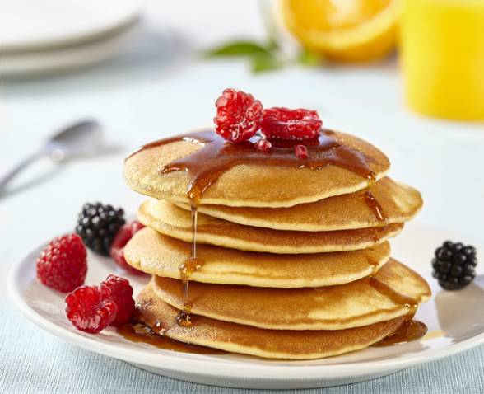
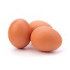
Ingredients :
- 3 eggs
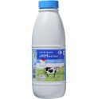
- 400 ml of milk
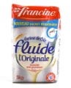
- 300 g of flour
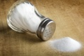
- 1 pinch of salt
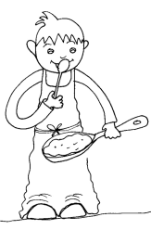
- 1 raising powder sachet

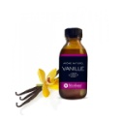
- Aroma : vanilla, rhum, lemon, orange blossom,…
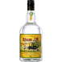
Steps :

- Wash your hands !

- In a bowl, pour the flour and the pinch of salt.

- Break the eggs 1 by 1 and mix.

- Add the milk slowly and mix well ! Important : beware of lumps !!
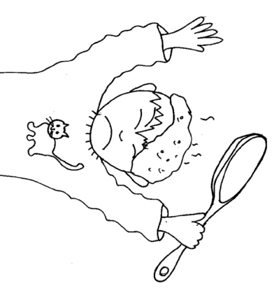
- Add the raising powder and the aroma. Mix again.

- Let it rest for an hour.

Now you can make the pancakes and enjoy !

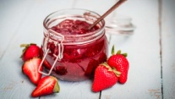
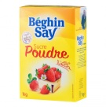
You can eat your pancakes with maple syrup, sugar or jam !

