Can or Can’t



Can you… ? Yes I can …
No I can’t …

 | Pronouns | Affirmative / Negative | Actions
SINGULAR | I | Can / Can’t | speak english
SINGULAR | You | Can / Can’t | ride a bike
SINGULAR | He / She / It | Can / Can’t | swim
PLURIAL | We | Can / Can’t | sing a song
PLURIAL | You | Can / Can’t | draw a flower
PLURIAL | They | Can / Can’t | play the guitar


Use can or can’ to complete the sentences.
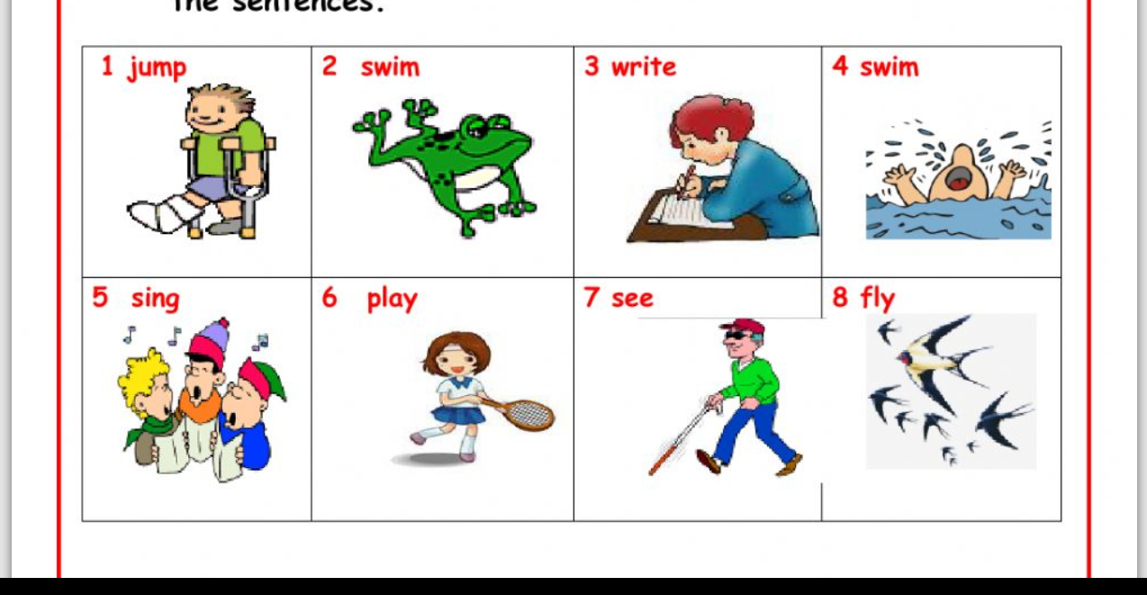

1) He can’t jump. 5) They _________ sing.

2) It __________ swim. 6) She __________ play.

3) She _________ write. 7) He ___________ see.

4) He __________ swim. 8) They __________ fly.

